Project title:
Animal Ethics # |  | Name of contact person:
Chief investigator: |  | Contact number:
Research Group: |  | After hours number:

Scoring of wellbeing will be performed relative to the following assessment criteria:
Criteria |  |  | Score
 |  |  | 0 |  |  | 1 (mild) | 2 (moderate) | 3 (severe)
Activity and responsiveness |  |  | Normal |  |  | Mild/slight reduction in activity relative to normal or previous observations | Isolated from cage-mates or obvious reduction in activity and responsiveness relative to normal or previous observations; alternatively, there is increased response to stimulus (e.g. appears agitated, twitching, easily started, or photophobic) | Stationary while awake for prolonged periods (>15min); when nudged, does not move, or makes poor attempts to move; collapsed and unable to right itself; persistent and prolonged fitting/ trembling (>1min)
Facial grimace  (see image 1) |  |  | Not present |  |  | Facial grimace is subtle or inconsistent (i.e. only 1 to 2 of the “indicators” demonstrated in image 1 are moderately present) | Facial grimace is moderate (i.e. at least 3 of the 5 “indicators” are “moderately present”) | Facial grimace is obvious (i.e. at least 3 of the 5 “indicators” are “obviously present”) however, there must also be indication of other generalised symptoms (e.g. hunching, reduced activity)
Coat condition (see image 2) |  |  | Normal |  |  | Coat does not appear entirely smooth, clean and silky (i.e. the coat appears slightly 'rough’) | Some indication of piloerection is present (i.e. 'rough’ coat), but it is not obvious over the mouse’s entire surface area | Generalised piloerection, i.e. obvious, very rough coat over majority of the body’s surface area (as demonstrated in image 2)
Body position/ posture  (see image 4) |  |  | Normal |  |  | Mild hunching  (see image 3) | Moderate hunching | Severe hunching: or arching and writhing (despite analgesia having been provided)
Respiratory function |  |  | Normal |  |  | - | Increased respiratory effort (mild increases in respiratory rate, increased abdominal movement) | Increased respiratory effort compromising normal behaviours (i.e. the animal is lethargic, isolated and inappropriately responsive); or has slowed respiratory rate and gasping; or is open mouth breathing; or has blue mucous membranes or extremities; or noisy breathing (e.g. respiratory “clicking”)
Tarsal swelling (see image 3) |  |  | Both hindlimbs are normal in appearance. No presence of redness or swelling. Normal joint gait and toe grip strength. |  |  | One or both hindlimbs appear red, mild inflamed with swelling surrounding the tarsal joint. Some reduction in limb/s movement and the limb/s may retract during restraint. Toe grip may be affected. | One or both hindlimbs are red, moderately inflamed and swelling surrounding the tarsal joint. Observable reduction in movement or limp present. Retraction of the limb/s during restraint. Toe grip is affected. | One or both hindlimbs are red, severe inflammation and swelling surrounding the tarsal joint with ulceration present. Limb movement severely affected to non-weight baring. Retraction of the limb/s during restraint. Toe grip is absent.
Body weight loss* |  |  | <5% |  |  | 5-9%  (relative to body weight recorded at the start of the experiment i.e. day 0) | 10-14% | ≥15%
*please note: body weight may not need to be measured at each monitoring point, particularly if monitoring is occurring frequently (as the handling associated with this procedure can be stressful for mice). In experimental mice that are asymptomatic, there is rarely reason to measure body weight more frequently than once a week. If disease symptoms present acutely body weight should be measured with appropriate frequency to appreciate impact to the animals (up to daily measurements). Where appropriate, body condition scoring (see image 5) may be used intermittently in place body weight measurements.
Cumulative Score: |  |  |  | Action, relative to cumulative score:
 |  | 0 |  |  | = no action (in addition to routine care and monitoring)
 |  | 1 to 4 |  |  | = symptoms observed, monitor at least daily (including all animals of similar treatment groups), if symptoms are unexpected seek veterinary advice
 |  | 5 to 11 |  |  | = monitor at least twice daily, provide food/water supplementation (e.g. wet mash or gel pack on the cage floor), if symptoms are unexpected seek veterinary advice
 |  | > 11 |  |  | = euthanasia is required (unless otherwise advised by a facility veterinarian)
 | *** A score of 3 in any one category = euthanasia is required (unless otherwise advised by a facility veterinarian) **

Specific actions relative to TARSL SWELLING scores:
Score 1 – Ensure the mice are housed with ‘soft bedding’ (e.g. paper bedding) and that food is offered on the cage floor (to reduce their interest in climbing the food hopper). Consider commencement of water treatment with pentosan polysulfide (especially for long-term studies). Short-term studies may consider oral or injectable preparations of pentosan, paracetamol, carprofen or meloxicam.
Score 2 – Multimodal analgesia is required. Examples include: pentosan and carprofen, meloxicam and buprenorphine, paracetamol and buprenorphine. Preparations of these drugs may be administered orally (ad lib) or via injection.
Score 3 – Euthanasia is required (unless otherwise advised by a facility veterinarian)

Comments:
- NSG mice should be routinely housed on ‘soft bedding’ as apart of normal husbandry
- Frequent handling should be avoided and forceful handling which places pressure on the tarsus should be avoided
- Analgesia combinations to avoid: 2x NSAIDs, administered together, as this will result in serious risks of side effects without benefit to analgesia e.g. meloxicam cannot be administered concurrently with carprofen. Note: paracetamol is not considered a “true” NSAID, and so it may be used concurrently with NSAIDs.
- Ad lib oral analgesia is generally the preferred route of administration for these animals, given it limits handling requirements (especially in long-term studies)
- For veterinary support, ensure contact is made with UQBR Veterinary Services <br.vetservices@uq.edu.au>

Image 1. The 5 “indicators” of facial grimace, as per Mouse Grimace Scale: https://www.nc3rs.org.uk/grimacescales
Please note: facial grimace can be subtle and requires experience to be able to assess accurately. If you are not comfortable assessing this parameter, you must seek training and support for this purpose – contact your Chief Investigator and the relevant animal facility staff.
 | Not present | Moderately present | Obviously present
Orbital tightening | 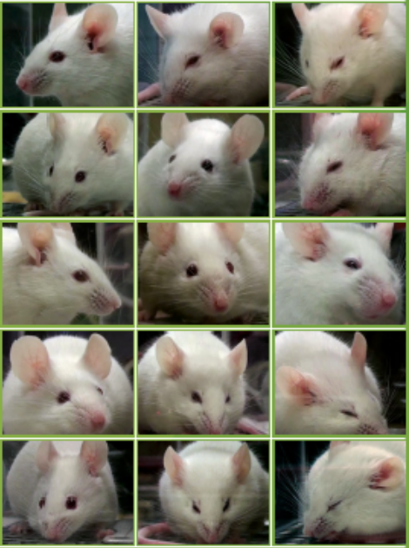
Nose bulge
Cheek bulge
Ear position
Whisker change

Image 2. Score 3 (severe) for the criteria: “coat condition”. This mouse has diffuse piloerection, image source: https://www.humane-endpoints.info/en
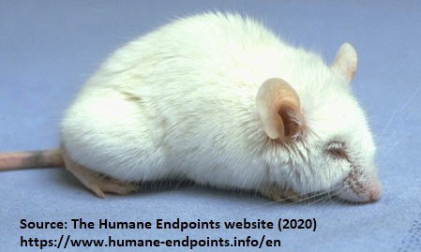

Image 3. Clinical scoring system for severity of tarsal lesions/swelling in immunocompromised strains of mice, image source: Campagna & Hernandez et al. Evaluation of Tarsal Lesions in Immunocompromised Mouse Strains, The Jackson Laboratory)
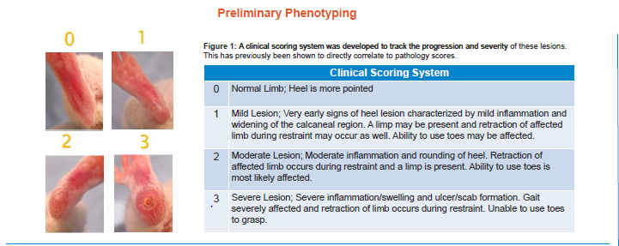
Image 4. Hunching, scored from normal (score 0) to severe (score 3), modified from: Sevcik MA, Jonas BM, Lindsay TH, et al. Endogenous opioids inhibit early-stage pancreatic pain in a mouse model of pancreatic cancer. Gastroenterology. 2006;131(3):900–910.
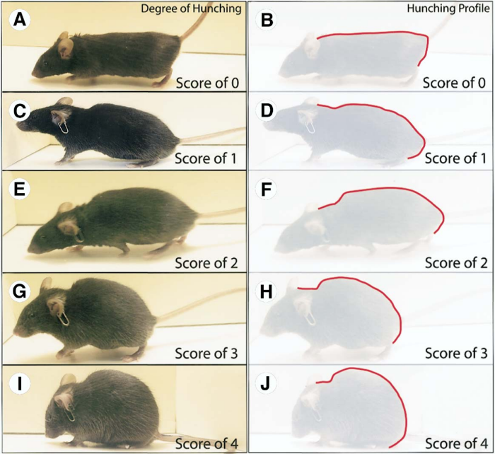
Please note: ear tag-identifiers (as displayed in this image) are generally not considered appropriate for use in mice, as there are other, more refined methods of individual identification.
Normal (score 0)
Mild hunching (score 1)
Severe hunching (score 3)
Moderate hunching (score 2)

Image 5: Mouse, Body Condition Score reference.
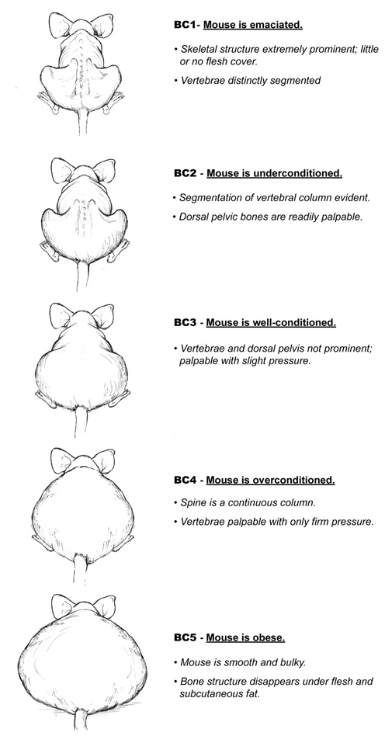
“Body Condition Scoring (BC) is a quick, easy and reliable method for assessing mouse health. It utilizes a scoring system of 1 to 5 with 3 being the optimal condition, 1 being emaciated and 5 being obese.” Source: Burkholder T, Foltz C, Karlsson E, Linton CG, Smith JM. Health Evaluation of Experimental Laboratory Mice. Curr Protoc Mouse Biol. 2012;2:145–165. [Body condition scores should be used with this score sheet “Standard Score Sheet for the assessment of wellbeing in mice” to avoid excessive handling (through repeated weighing) when performing frequent monitoring. Body condition scores complement body weight measurements; however, their use does not contribute to the score sheet’s “cumulative score”]

Monitoring record for the assessment of wellbeing in mice
(see “Standard Score Sheet… NSG mice” for a description of the scores relative to the criteria below)
Project title: AEC approval #:
Chief Investigator: Name of contact person: Contact number: After hours:
Experimental/ Treatment Group: Mouse ID: ____________
Date
Day (of study)
Criteria (scores 0 to 3):
Activity & responsiveness
Facial grimace
Coat condition
Body position/ posture
Respiratory function
Tarsal swelling
Body weight loss*
Body weight change (%)
Body weight (g)
Cumulative score
(i.e. total)
Comments:
(please use a key)
*Please note: body weight may not need to be measured at each monitoring point. Refer to “Standard Score Sheet… NSG mice” for details.
Cumulative score: |  |  | Action, relative to cumulative score:
 |  | 0 |  | = no action (in addition to routine care and monitoring)
 |  | 1 to 4 |  | = symptoms observed, monitor at least daily (including all animals of similar treatment groups), consider seeking veterinary advice
 |  | 5 to 11 |  | = monitor at least twice daily, provide food/water supplementation (e.g. wet mash or gel pack on the cage floor), consider seeking veterinary advice
 |  | > 11 |  | = euthanasia is required (unless otherwise advised by a facility veterinarian)
 | *** A score of 3 in any one category = euthanasia is required (unless otherwise advised by a facility veterinarian) ***
Original mouse weight (g) |  | 16 | 17 | 18 | 19 | 20 | 21 | 22 | 23 | 24 | 25 | 26 | 27 | 28 | 29 | 30
Weight loss (%) | 5% | 15.2 | 16.2 | 17.1 | 18.1 | 19.0 | 20.0 | 20.9 | 21.9 | 22.8 | 23.8 | 24.7 | 25.7 | 26.6 | 27.6 | 28.5
 | 10% | 14.4 | 15.3 | 16.2 | 17.1 | 18.0 | 18.9 | 19.8 | 20.7 | 21.6 | 22.5 | 23.4 | 24.3 | 25.2 | 26.1 | 27.0
 | 15% | 13.6 | 14.5 | 15.3 | 16.2 | 17.0 | 17.9 | 18.7 | 19.6 | 20.4 | 21.3 | 22.1 | 23.0 | 23.8 | 24.7 | 25.5

Monitoring record for the assessment of wellbeing in mice
(see “Standard Score Sheet… NSG mice” for a description of the scores relative to the criteria below)
Project title: Name of contact person:
Chief Investigator: AEC approval #: Contact number:
Date: __________ Day of study: __________ After hours:
 |  | Criteria (scores 0 to 3):
Mouse ID# | Treatment group | Activity & responsiveness | Facial grimace | Coat condition | Body position / posture | Respiratory function | Tarsal swelling | Body weight loss* | Body weight change (%) | Body weight (g) | Cumulative score (i.e. total) | Comments:
*Note: body weight may not need to be measured at each monitoring point. Refer to “Standard Score Sheet… NSG mice” for details.
Cumulative score: |  |  | Action, relative to cumulative score:
 |  | 0 | = no action (in addition to routine care and monitoring)
 |  | 1 to 4 | = symptoms observed, monitor at least daily (including all animals of similar treatment groups), consider seeking veterinary advice
 |  | 5 to 11 | = monitor at least twice daily, provide food/water supplementation (e.g. wet mash or gel pack on the cage floor), consider seeking veterinary advice
 |  | > 11 | = euthanasia is required (unless otherwise advised by a facility veterinarian)
 | *** A score of 3 in any one category = euthanasia is required (unless otherwise advised by a facility veterinarian)***

Original mouse weight (g) |  | 16 | 17 | 18 | 19 | 20 | 21 | 22 | 23 | 24 | 25 | 26 | 27 | 28 | 29 | 30
Weight loss (%) | 5% | 15.2 | 16.2 | 17.1 | 18.1 | 19.0 | 20.0 | 20.9 | 21.9 | 22.8 | 23.8 | 24.7 | 25.7 | 26.6 | 27.6 | 28.5
 | 10% | 14.4 | 15.3 | 16.2 | 17.1 | 18.0 | 18.9 | 19.8 | 20.7 | 21.6 | 22.5 | 23.4 | 24.3 | 25.2 | 26.1 | 27.0
 | 15% | 13.6 | 14.5 | 15.3 | 16.2 | 17.0 | 17.9 | 18.7 | 19.6 | 20.4 | 21.3 | 22.1 | 23.0 | 23.8 | 24.7 | 25.5

